Analyzing Stroke Dataset with Logistic Regression
Problem:
A stroke occurs when blood flow to the brain and can be deadly if not treated immediately. Risk factors that increase the likelihood of developing a stroke include age, bmi, elevated blood glucose level, smoking status, hypertension, and heart disease. Signs that someone is having a stroke include slurred speech, confusion, trouble walking, drooped face, and/or paralysis of arms (Shruthi, 2024). There are roughly 795,000 cases of stroke in the United States per year (Shruthi, 2024). Finding key indicators that are predictive of having a stroke is important so that at risk patients can take action and make some lifestyle modifications before it is too late.

Objective:
The objective of this analysis is to see which risk factors have the most influence on the onset of developing a stroke. For example, does smoking have the biggest impact on the development of stroke? Another question that can be researched is if there is a positive correlation between BMI and stroke occurrence. Three other variables that should be researched is if there is a relationship between hypertension, age, or gender and stroke occurrence. This information will then be used to create a logistic regression model that can predict one's likelihood of having a stroke.

Exploratory Analysis:
The data was collected by the World Health Organization (WHO). The continuous variables include age, bmi, and average glucose level. The categorical variables include gender, hypertension, heart disease, work type, marital status, residence type, and smoking status.
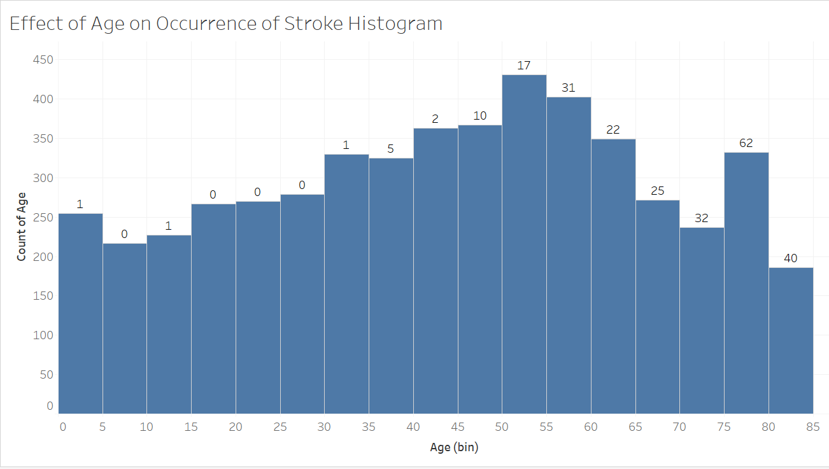

Data Formatting:
BMI was rounded to the nearest integer. Then, all rows where the patients’ BMI or smoking status was unknown were deleted. Since smoking status likely significantly increases the risk of having a stroke, all rows where smoking status was unknown were deleted. Furthermore, rows where patients had a BMI >70 were also deleted since those are most likely incorrect entries. After this, we are left with 3423 rows of data.
Model Fitting:
First, the variables were split into train and test groups. The test size was 0.2 which means the remaining 80% was used to train the model. Then the model score was found which models the probability that the response belongs to a particular category. For example, a higher average blood glucose level is more likely to belong in the stroke category. The logistic regression score was then calculated which estimates the value of an unknown dependent variable in the model. Finally, a confusion matrix was created along with the classification report. A confusion matrix tells us the number of true positives, true negatives, false positives, and false negatives. A classification report gives us the precision, recall, and f-1 score. Precision is found by dividing the number of true positives by false positives + false negatives (Koehrsen, 2023). It describes the model’s ability to correctly identify true positives (Koehrsen, 2023). Recall is found by dividing the number of true positives by true positives + false negatives (Koehrsen, 2023). It describes the model’s ability to correctly identify true positives from all positive samples in the dataset (Accuracy vs. precision vs. recall in machine learning: what's the difference?). The F1 score is the harmonic mean of precision and recall and considers both metrics (Koehrsen, 2023). The F1 score should be maximized when creating a model with optimal balance between precision and recall (Koehrsen, 2023).

Model Evaluation:
The logistic regression model achieved a model score of 0.961 indicating that the model is an excellent fit for the data. The model identified 658 true positives and no true negatives. Likewise, there were 26 false negatives and one false positive. This means that the model is more prone to misclassifying an individual as not having a stroke than misclassifying an individual as having a stroke. Based on a precision score of 96% for precision, the model correctly classified positive predictions 96% of the time. The recall was almost perfect with a score of approximately 100% meaning the model correctly identified positives (there was only one false positive). The f1 score of 98% reflects an optimal balance between precision and recall.

Conclusion:
The three biggest risk factors that increase the risk of developing a stroke are a high BMI (> 25), elevated average glucose level, and older age. Therefore, recommendations to decrease the risk of having a stroke are to maintain a healthy body weight and manage blood glucose levels by exercising regularly and eating healthily.

References

Accuracy vs. precision vs. recall in machine learning: what’s the difference? (n.d.). Www.evidentlyai.com. https://www.evidentlyai.com/classification-metrics/accuracy-precision-recall#:~:text=Recall%20is%20a%20metric%20that
‌Koehrsen, W. (2023, March 8). Precision and Recall: How to Evaluate Your Classification Model [Review of Precision and Recall: How to Evaluate Your Classification Model]. Builtin. https://builtin.com/data-science/precision-and-recall#:~:text=Recall%3A%20the%20ability%20of%20a%20classification%20model%20to%20identify%20all,precision%20using%20the%20harmonic%20mean
Shruthi, N. (2024, June 17). Most Common Warning Signs of Stroke. WebMD. https://www.webmd.com/stroke/signs-of-stroke

